**Q1 )Types of Plan (Page 207) (BTSF)**

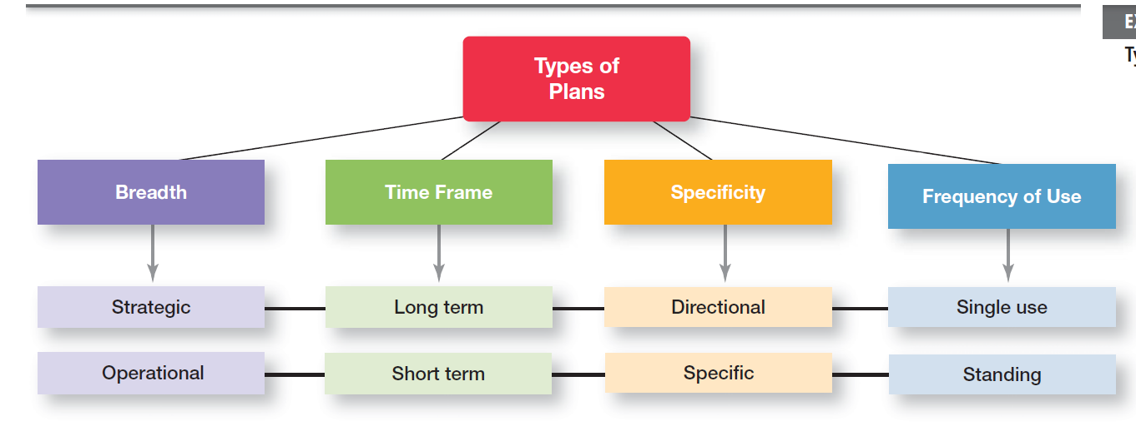

The most popular ways to describe organizational plans are breadth (strategic versus operational), time frame (short term versus long term), specificity (directional versus specific), and frequency of use (single use versus standing). These types of plans aren’t independent. That is, strategic plans are usually long term, directional, and single use whereas operational plans are usually short term, specific, and standing.

**Strategic Plans:** These are plans that apply to the entire organization and establish the organization’s overall goals.

**Operational Plans:** Plans that encompass a particular operational area of the organization are called operational plans. These two types of plans differ because strategic plans are broad while operational plans are narrow.

**Long Term Plans:** Long-term used to mean anything over seven years. We define long-term plans as those with a time frame beyond three years.

**Short-term Plans:** These plans cover one year or less. Any time period in between would be an intermediate plan.

**Specific Plans:** These plans are clearly defined and leave no room for interpretation. A specific plan states its objectives in a way that eliminates ambiguity and problems with misunderstanding.

**Directional Plans:** These are flexible plans that set out general guidelines. They provide focus but don’t lock managers into specific goals or courses of action. When uncertainty is high and managers must be flexible in order to respond to unexpected changes, directional plans are preferable.

**Single-use Plan:** A single-use plan is a one-time plan specifically designed to meet the needs of a unique situation.

**Standing Plans:** are ongoing plans that provide guidance for activitiesperformed repeatedly. Standing plans include policies,rules, and procedures.

**Q2) The Downside of Traditional Goal Setting (Page 209) (TDDI)**

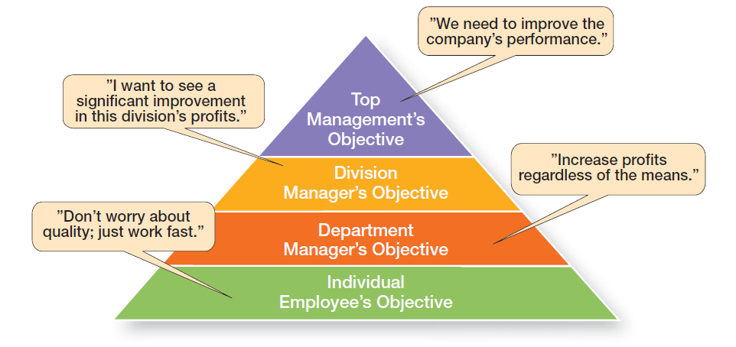

**Q3) Steps in MBO (Page 210) (OMUDAIRR)**

1. **Organizational Objectives:** The organization’s overall objectives and strategies are formulated.
2. **Major Objectives:** Major objectives are allocated among divisional and departmental units.
3. **Unit Objectives:** Unit managers collaboratively set specific objectives for their units with their managers.
4. **Departmental Objectives:** Specific objectives are collaboratively set with all department members.
5. **Action Plans:** Action plans, defining how objectives are to be achieved, are specified and agreed upon by managers and employees.
6. **Implementation of Action Plans:** The action plans are implemented.
7. **Review Progress:** Progress toward objectives is periodically reviewed, and feedback is provided.
8. **Rewards for Success:** Successful achievement of objectives is reinforced by performance-based rewards

**4) Significance of Well-Written Goals: (OMCCWC)**

1. **Outcome Oriented:** Written in terms of outcomes rather than actions
2. **Measurable and quantifiable**
3. **Clarity w.r.t Time:** Clear as to a time frame
4. **Challenging yet attainable**
5. **Written** down
6. **Communicated** to all necessary organizational members

**5) Planning and organizational levels**

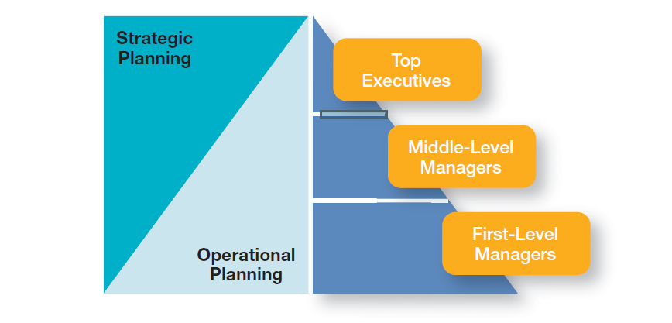

**6)**

**CRITISIZMS OF PLANNING:**

* Planning may create rigidity
* Plans cannot be developed for dynamic environments
* Formal plans cannot replace intuition and creativity
* Planning focuses managers’ attention on today’s competition, not tomorrow’s survival
* Formal planning reinforces today’s success, which may lead to tomorrow’s failure

**7) Purpose of Organizing: (WTCCEER)**

* **Work Division:** Divides work to be done into specific jobs and departments.
* **Task Assignment:** Assigns tasks and responsibilities associated with individual jobs.
* **Coordination of Tasks:** Coordinates diverse organizational tasks.
* **Cluster of Jobs:** Clusters jobs into units.
* **Establishment of Relationships:** Establishes relationships among individuals, groups, and departments.
* **Establishment of Line of Authority:** Establishes formal lines of authority.
* **Resource Allocation:** Allocates and deploys organizational resources.

**8) Departmentalization**

How jobs are grouped together is calleddepartmentalization.

**Types of Departmentalization (FPPGC)**

* **Functional**

Grouping jobs by functions performed

* **Product**

Grouping jobs by product line

* **Process**

Grouping jobs on the basis of product or customer flow

* **Geographical**

Grouping jobs on the basis of territory or geography

* **Customer**

Grouping jobs by type of customer and needs

**9) Centralization versus Decentralization (ECDDRSI)**

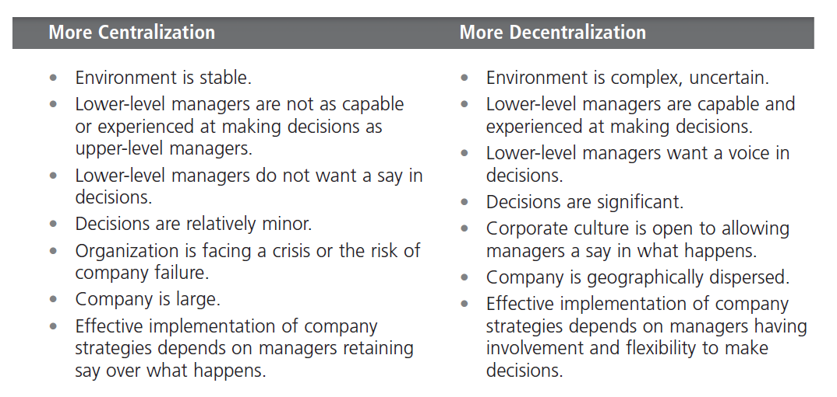

|  |  |  |
| --- | --- | --- |
| **CENTRALIZATION** |  | **DECENTRALIZATION** |
| Environment is stable. | **ENVIRONMENT STABILITY** | Environment is complex, uncertain |
| Lower-level managers are not as capable or experienced at making decisions as upper-level managers. | **CAPABILITY OF LOW-LEVEL MANAGERS** | Lower-level managers are capable and  experienced at making decisions. |
| Lower-level managers do not want a say in  decisions. | **DECISION BY LOW LEVEL MANAGERS** | • Lower-level managers want a voice in  Decisions |
| Decisions are relatively minor. | **DECISIONS SIZE** | Decisions are significant. |
| Organization is facing a crisis or the risk of  company failure. | **RISK** | Corporate culture is open to allowing  managers a say in what happens. |
| Company is large. | **SIZE OF COMPANY** | Company is geographically dispersed |
| Effective implementation of company  strategies depend on managers retaining  say over what happens. | **IMPLEMENTATION OF STRATEGIES** | Effective implementation of company  strategies depend on managers having  involvement and flexibility to make  decisions. |
|  |  |  |

**Contingency Factors Affecting Structural Choice (SSTE)**

There are several contingency factors that influence the decision namely:

**1. Strategy and Structure**

Whatever is an organizations structure it should always be able to facilitate the organization with goal achievement. This is so because goals play a very crucial role for organizations strategy as both strategy and structures are relatively linked together.

**2. Size and Structure**

Many evidences have been found that size of an organization affects their structure. Organization with over 2000 plus employees are considered for largest and they will have more number of specialization, centralization, departmentalization than those of other smaller organizations. Once an organization grows past a certain size, size has less influence on structure. Adding 500 employees to a 2000 employee’s organization would not affect its structure much because it is already mechanistic. But addition of 500 employees to an organization with 300 employees will help them to be mechanistic.

**3. Technology and Structure**

Every organization uses some form of technology to convert its inputs into outputs. Technology’s effect on structure. The firms is divided into three distinct technologies that had increasing levels of complexity and sophistication. The first category is **unit production**, described the production of items in units or small batches. The second category is **mass production**, described large batch manufacturing. Finally, the third and most technically complex group, **process production**, included continuous process production.

**4. Environmental Uncertainty and Structure**

In stable and simple environments, mechanistic designs can be more effective. On the other hand, the greater the uncertainty, the more an organization needs the flexibility. Manager need try to minimize environmental uncertainty by adjusting the organization’s structure.

**Hofstede Culture Dimensions: (PIMULI)**

POWER DISTANCE

This dimension deals with the fact that all individuals in societies are not equal – it expresses the attitude of the culture towards these inequalities amongst us. Power Distance is defined as ***the extent to which the less powerful members of institutions and organisations within a country expect and accept that power is distributed unequally.***

With an intermediate score of 55, it is not possible to determine a preference for Pakistan in this dimension.

INDIVIDUALISM

The fundamental issue addressed by this dimension is ***the degree of interdependence a society maintains among its members.*** It has to do with whether people´s self-image is defined in terms of “I” or “We”.In Individualist societies people are supposed to look after themselves and their direct family only. In Collectivist societies people belong to ‘in groups’ that take care of them in exchange for loyalty.

Pakistan, with a very low score of 14, is considered a collectivistic society. This is manifest in a close long-term commitment to the member ‘group’, be that a family, extended family, or extended relationships. Loyalty in a collectivist culture is paramount, and over-rides most other societal rules and regulations. The society fosters strong relationships where everyone takes responsibility for fellow members of their group. In collectivist societies offence leads to shame and loss of face, employer/employee relationships are perceived in moral terms (like a family link), hiring and promotion decisions take account of the employee’s in-group, management is the management of groups.

MASCULINITY

A high score (Masculine) on this dimension indicates that the society will be driven by competition, achievement and success, with success being defined by the winner / best in field – a value system that starts in school and continues throughout organisational life.

A low score (Feminine) on the dimension means that the dominant values in society are caring for others and quality of life. A Feminine society is one where quality of life is the sign of success and standing out from the crowd is not admirable. ***The fundamental issue here is what motivates people, wanting to be the best (Masculine) or liking what you do (Feminine).***

Pakistan scores 50 on this dimension, and as this is an exactly intermediate score it cannot be said if Pakistan has a preference to Masculinity of femininity.

UNCERTAINTY AVOIDANCE

The dimension Uncertainty Avoidance has to do with the way that a society deals with the fact that the future can never be known: should we try to control the future or just let it happen? This ambiguity brings with it anxiety and different cultures have learnt to deal with this anxiety in different ways. ***The extent to which the members of a culture feel threatened by ambiguous or unknown situations and have created beliefs and institutions that try to avoid these*** is reflected in the UAI score.

Pakistan scores 70 on this dimension and thus has a high preference for avoiding uncertainty. Countries exhibiting high Uncertainty Avoidance maintain rigid codes of belief and behaviour and are intolerant of unorthodox behaviour and ideas. In these cultures there is an emotional need for rules (even if the rules never seem to work) time is money, people have an inner urge to be busy and work hard, precision and punctuality are the norm, innovation may be resisted, security is an important element in individual motivation.

LONG TERM ORIENTATION

This dimension describes ***how every society has to maintain some links with its own past while dealing with the challenges of the present and future***, and societies prioritise these two existential goals differently. Normative societies. which score low on this dimension, for example, prefer to maintain time-honoured traditions and norms while viewing societal change with suspicion. Those with a culture which scores high, on the other hand, take a more pragmatic approach: they encourage thrift and efforts in modern education as a way to prepare for the future.

With an intermediate score of 50, the culture of Pakistan cannot be said to indicate a preference.

INDULGENCE

One challenge that confronts humanity, now and in the past, is the degree to which small children are socialized. Without socialization we do not become “human”. This dimension is defined as***the extent to which people try to control their desires and impulses***, based on the way they were raised. Relatively weak control is called “Indulgence” and relatively strong control is called “Restraint”. Cultures can, therefore, be described as Indulgent or Restrained.

Pakistan, with an extremely low score of 0 on this dimension, can be said to be a very Restrained society. Societies with a low score in this dimension have a tendency to cynicism and pessimism. Also, in contrast to Indulgent societies, Restrained societies do not put much emphasis on leisure time and control the gratification of their desires. People with this orientation have the perception that their actions are Restrained by social norms and feel that indulging themselves is somewhat wrong.

**Changes Affecting Manager’s Job (External Factors)**

1. **Manage Jobs and Employment**

The impact of external factors on jobs and employment is one of the most powerful constraints mangers face

1. **Manage Environmental Uncertainty**

**Environmental uncertainty:** the degree of change and complexity in an organization’s environment

* 1. Degree of Change: stable to dynamic
  2. Environmental Complexity: simple to complex

1. **Manage Stakeholder Relationships**

**Stakeholders:** any constituencies in the organization’s environment that are affected by an organization’s decisions and actions

**REWARDS & CHALLENGES:**

1. **CHALLENGES:**

* Can be a thankless job
* May entail clerical type duties
* Managers also spend significant amounts of time in meetings and dealing with interruptions
* Managers often have to deal with a variety of personalities and have to make do with limited resources

1. **REWARDS:**

* Responsible for creating a productive work environment
* Recognition and status in your organization and in the community
* Attractive compensation in the form of salaries, bonuses, and stock options

**Hawthorne Studies**

Hawthorne Studies, a series of studies conducted at the Western Electric Company Works in Cicero, Illinois. These studies, which started in 1924, were initially designed by Western Electric industrial engineers as a scientific management experiment. They wanted to examine the effect of various lighting levels on worker productivity. Like any good scientific experiment, control and experimental groups were set up with the experimental group being exposed to various lighting intensities, and the control group working under a constant intensity. If you were the industrial engineers in charge of this experiment, what would you have expected to happen? It’s logical to think that individual output in the experimental group would be directly related to the intensity of the light. However, they found that as the level of light was increased in the experimental group, output for both groups increased. Then, much to the surprise of the engineers, as the light level was decreased in the experimental group, productivity continued to increase in both groups. In fact, a productivity decrease was observed in the experimental group only when the level of light was reduced to that of a moonlit night. What would explain these unexpected results? The engineers weren’t sure, but concluded that lighting intensity was not directly related to group productivity, and that something else must have contributed to the results. They weren’t able to pinpoint what that “something else” was, though In 1927, the Western Electric engineers asked Harvard professor Elton Mayo and his associates to join the study as consultants. Thus began a relationship that would last through 1932 and encompass numerous experiments in the redesign of jobs, changes in workday and workweek length, introduction of rest periods, and individual versus group wage plans.7 For example, one experiment was designed to evaluate the effect of a group piecework incentive pay system on group productivity. The results indicated that the incentive plan had less effect on a worker’s output than did group pressure, acceptance, and security. The researchers concluded that social norms or group standards were the key determinants of individual work behavior. Scholars generally agree that the Hawthorne Studies had a game-changing impact on management beliefs about the role of people in organizations. Mayo concluded that people’s behavior and attitudes are closely related, that group factors significantly affect individual behavior, that group standards establish individual worker output, and that money is less a factor in determining output than are group standards, group attitudes, and security. These conclusions led to a new emphasis on the human behavior factor in the management of organizations. Although critics attacked the research procedures, analyses of findings, and conclusions, it’s of little importance from a historical perspective whether the Hawthorne Studies were academically sound or their conclusions justified. What is important is that they stimulated an interest in human behavior in organizations.

**Popular Contingency Variables (SREI)**

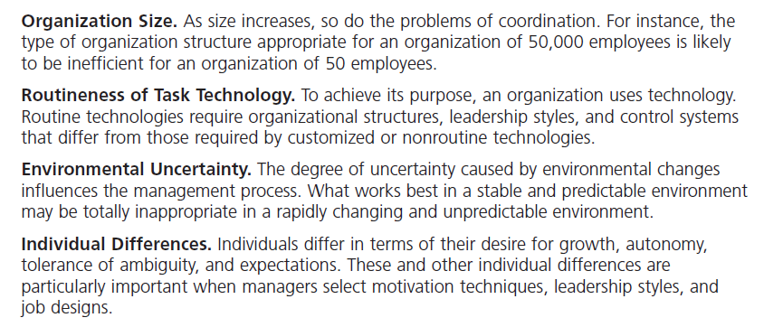

**Contingency approach**

The contingency approach says that organizations are different, face different situations, and require different ways of managing. It helps us understand management because it stresses there are no simplistic or universal rules for managers to follow. Instead, managers must look at their situation and determine that if this is the way my situation is, then this is the best way for me to manage.

**Organization as an Open System**

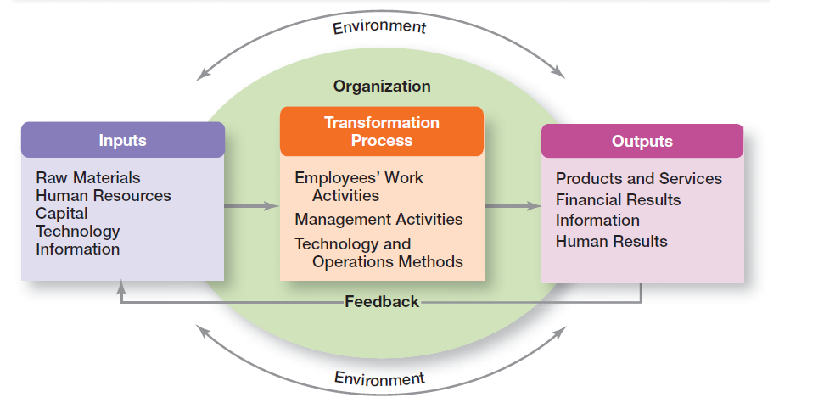

An organization takes in inputs (resources) from the environment and transforms or processes these resources into outputs that are distributed into the environment. The organization is “open” to and interacts with its environment.

Any organizational system is composed of three related parts: inputs, transformations, and outputs. Inputs consist of human or other resources, such as information, energy, and materials, coming into the system. Inputs are acquired from the system’s external environment. In each case, the system obtains resources from its external environment. Transformations are the processes of converting inputs into outputs. Outputs are the results of what is transformed by the system and sent to the environment. Thus, inputs that have been transformed represent outputs ready to leave the system.

**Chain of Command**

The chain of command is the line of authority extending from upper organizational levels to lower levels, which clarifies who reports to whom. Managers need to consider it when organizing work because it helps employees with questions such as “Who do I report to?” or “Who do I go to if I have a problem?” To understand the chain of command, you have to understand three other important concepts: authority, responsibility, and unity of command.

**Authority**

Authority refers to the rights inherent in a managerial position to tell people what to do and to expect them to do it. The acceptance view of authority says that authority comes from the willingness of subordinates to accept it

**Responsibility**

When managers use their authority to assign work to employees, those employees take on an obligation to perform those assigned duties. This obligation or expectation to perform is known as responsibility

**Unity of Command**

The unity of command principle states that a person should report to only one manager. Without unity of command, conflicting demands from multiple bosses may create problems.

**Span of Control**

The number of employees a manager can efficiently and effectively manage

The traditional view of span of control was that managers should directly supervise no more than five to six individuals. The contemporary view is that the span of control depends on the skills and abilities of the manager and the employees and on the characteristics of the situation.

**Mechanistic versus Organic Structure**

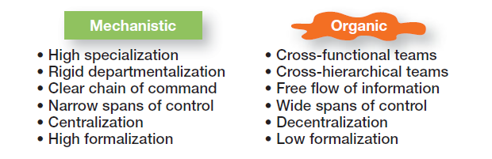

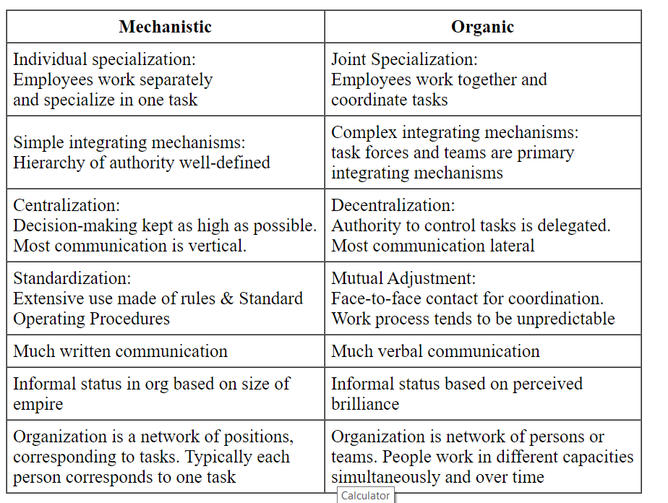**­­­­­**

**changes affecting managers job: (DIIS)**

**digital workplace:**

**1- shifting organizational boundaries**

**2- work life personal life balance**

**3- easy comunication**

**4-empowered employees**

**5-more mobile workforce**

**increased competitiveness:**

**1- creativity**

**2-globalization**

**3-customer service**

**4-efficiency/productivity**

**increased emphasis on managerial ethics:**

**1-increased accountabilty**

**2-redefined values**

**3-rebuild trust**

**security threats:**

**1-risk managment**

**2-uncertainty over future prices**

**3-restructured workplaces**

**4-employee assistance**

**5-globalization concern**

**6-discrimination concerns**